|  |
| --- |
| SoundRule: Final Document |
| Project 2 |
| CS-GY 6083 Principles of Database Systems ,under Prof : Torsten Suel |

**By : Ujjawal Gupta**

**Ajay Shete**

**INDEX**

1. Introduction ……………………………………………………..………………….……………………………. 2
2. Entity Relationship Diagram ………………………………………………..…….………………………. 3
3. Design Assumptions …………………………………………………………..…………….………………… 4
4. Converting ER diagram into relational database model/Schema ………………………… 4
5. UI description ……………………………….……………………………………………………………………. 6
6. Code Explanation ………….…………………………………………………………………………………. 13
7. Future consideration ……………………………………………………………………………………….. 18

**SoundRule**

Let The Music Play!

Introduction

SoundRule is an online music streaming website for users to listen to their favorite artist and their favorite music for free. Every user has to register, using a unique username, email id, city the user lives in and a password. The user may create a playlist, like an artist, rate a song or follow other users. Once the user registers it can login and change his details.

The website will provide a list of tracks along with their genre and artist description. Same track can be in multiple locations i.e. a solo song, Album or a user Playlist. So when the user will search a particular song or artist the text will be searched through track and artist tables. The user can mark its playlist public or private. To implement this we have created a view for public playlists. So every time a user creates a new playlist script will check whether the playlist type is private or public, if its private it will be added to playlist database only, and if its public the entry will be added to both playlist database and public_playlists view.

A history of number of times a song is played by user is maintained at the backend. To identify the popularity if a song, an album or a playlist three tables have been made history, playlist counter and album counter. So, when the user searches a song or an artist, it will be presented with the search results from tracks, Album or Playlist. Whichever option the user chooses to play the data entry will be made accordingly in that table. For example, the user choses to play the song from a playlist, an entry will be made in two tables i.e. playlist counter and history. So we assume that a playlist is played if any one song of the playlist is played. And depending on that we can calculate the popularity of any album or playlist.

The user can like an artist or rate a particular track on the scale of 1 to 5. So, if we have to check the popularity if a particular song or an artist we can use the Like and Rating tables in our schema.

The other feature that this website offers is that a user can follow other users, depending upon the interests and the popularity of the user’s playlists. We have not implemented a method to follow a playlist, you can access any user's playlist of it is publicly available, but you cannot like/rate that playlist. To know which user is following which other user, or in other words, to know which users are followed by which other users, we create a Follow table. This table is a self-loop to User table. It stores the uname of the user that follows the other user and the uname of the other user. The attributes are renamed for the table as user, followedby.

The website is designed using MySQL as database server. Further, backend scripting is done in PHP and Front end will be designed using HTML5, CSS3 and JavaScript. WAMP is the local host server application that will be used for the website.

**Entity Relationship Diagram**

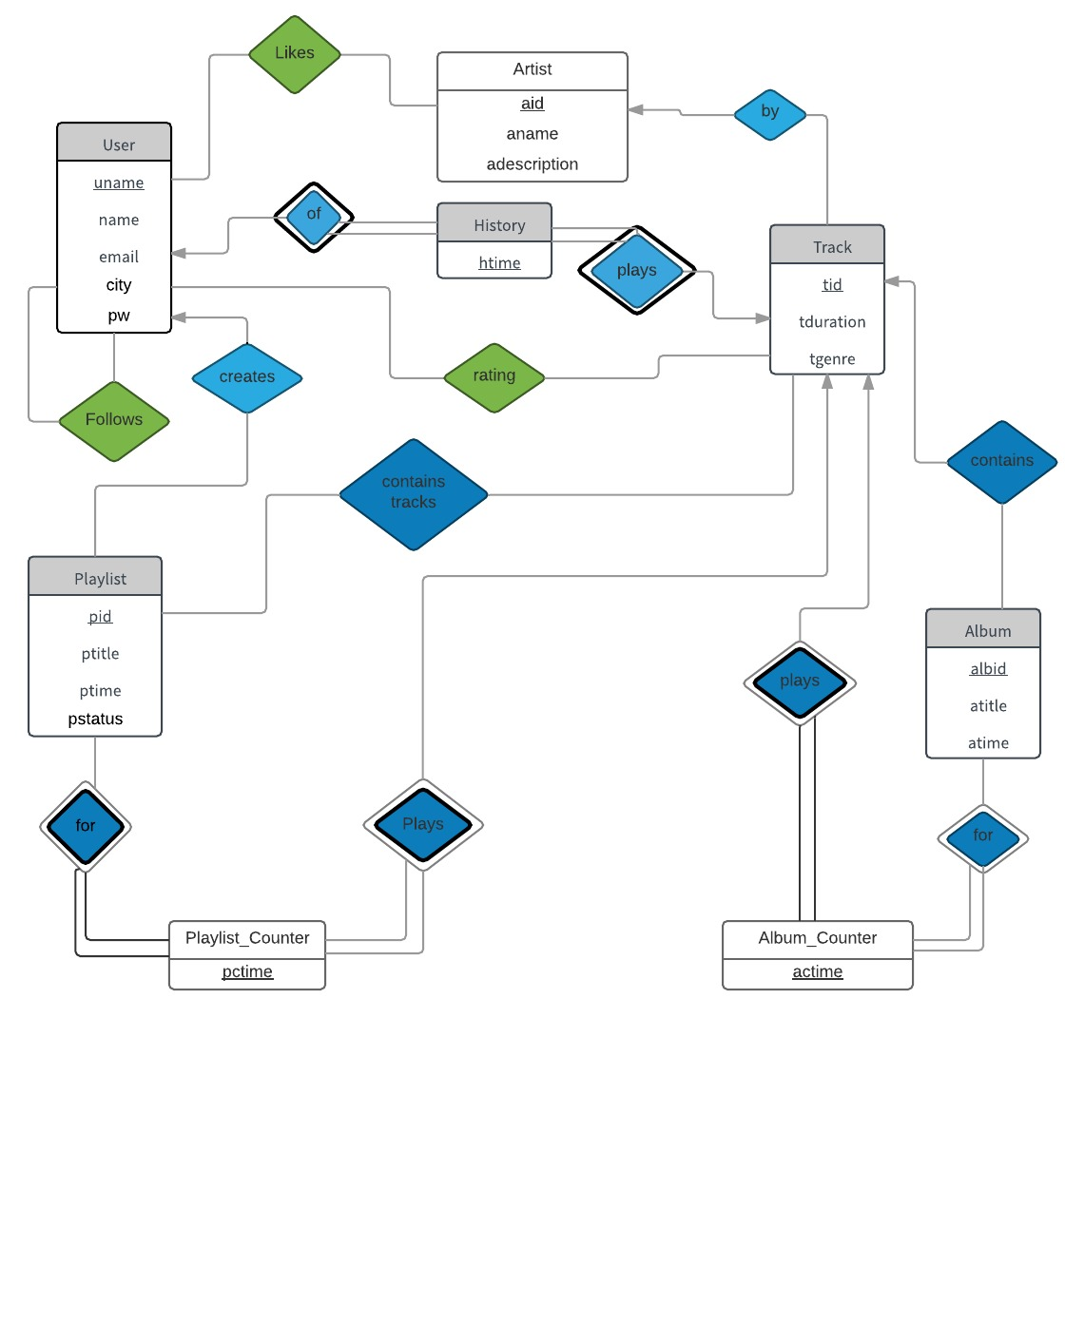

**Design Assumptions**

1. Users will have to register by providing username, password, name, email and city. They will be able to create their playlists separately.
2. The Artist table stores the detail of all artists. If there are multiple artists performing on a track their collaboration will be stored as a unique aid.
3. A user can follow other users, but they cannot follow any specific playlist. Additionally, the User can also like an artist.
4. A separate table has been designed to keep tab of all the tracks that are added in the playlist and verify when the user played the track from that playlist.
5. We have implemented a similar structure for the Album & Album_Counter.
6. The popularity of a playlist can be determined by calculating the number of times a song from that playlist was played. For this purpose, we have implemented a Playlist_Counter table.
7. Similarly, we can also find out the popularity of the Albums by verifying the Album_Counter table.
8. A history of the tacks played by the user is maintained in the history table. So if a track played is also available in an album or a playlist the entries will be made both to history table as well as respective counter table.
9. The user can choose to keep his Playlist private or public, and we will allow other users to access the songs by using the Playlist’s view table.

**Converting ER diagram into relational database model/Schema**

* User (**uname**, name, email, ucity, pw)
* Artist (**aid**, aname, adesc)
* Track (**tid**, ttitle, tdur, genre, aid,abid)

Foreign key (aid) references Artist (aid)

* History (**uname, tid, htime**)

Foreign key (uname) references User (uname)

Foreign key (tid) references Track (tid)

* Rating (**uname, tid**, rtime, score)

Foreign key (uname) references User (uname)

Foreign key (tid) references Track (tid)

* Album (**abid**, abtitle, abtime)
* Album Counter (**abid, tid, actime**)

Foreign key (abid) references Album (abid)

Foreign key (tid) references Track (tid)

* Playlist (**pid**, ptitle, pdate, ptype, uname)

Foreign key (uname) references User (uname)

* Playlist Tracks (**pid, tid**)

Foreign key (pid) references Playlist (pid)

Foreign key (tid) references Track (tid)

* Playlist Counter (**pid, tid, pctime**)

Foreign key (pid) references Playlist (pid)

Foreign key (tid) references Track (tid)

* Follow (**user, followedby**)

Foreign key (uname) references User (uname)

Foreign key (followedby) references User (uname)

Also, to distinguish between public and private playlists we have created **a view** for public playlists using:

create View **public_playlists**(pid, ptitle, pdate, uname) as

(select pid, ptitle , pdate, uname

from playlist

where ptype = "public")

**UI description**

**Login Page**

We require user to login first before entering the website, this model would have been helpful, even when the Music streaming service was paid, So user needs to first Authenticate and then he/she can enter start playing Music. So the user will first see this screen.

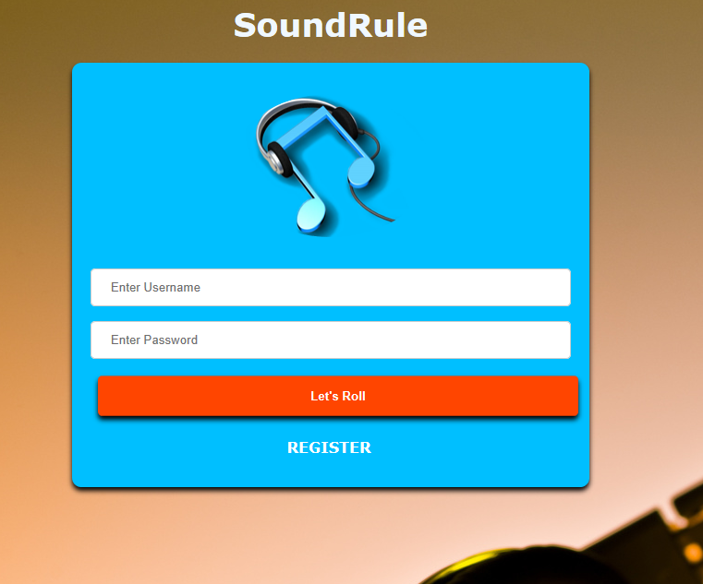

**Register**

If the user is not registered then user has to first register, by entering its name, city email address a unique uname and a password.

After Registration user will be requested to login again.

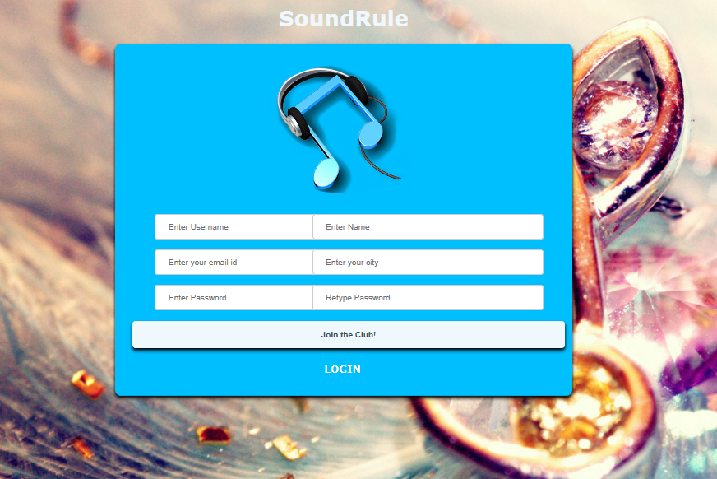

**Main Page**

After Login in user will be greeted with a welcome message and he/she will receive following options on the main page.

1. Search their favorite songs, artists and albums.
2. Browse through all available Albums
3. Open their profile page
4. Browse through all available Artists.

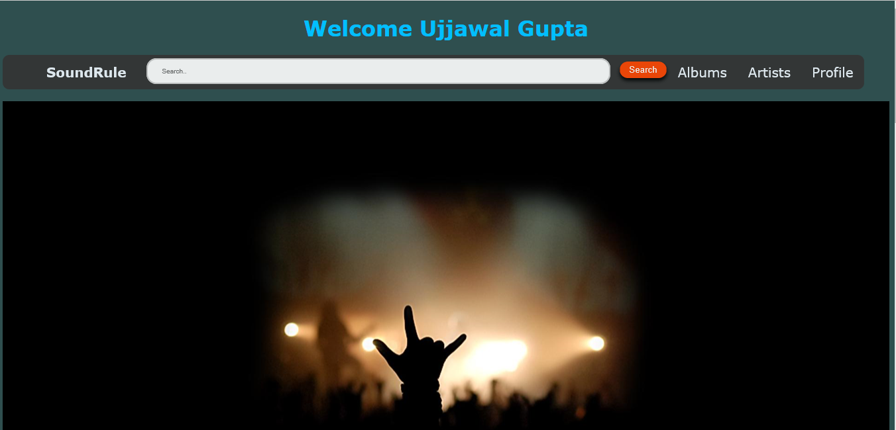

As we scroll down on the page we also see tile representation of popular artists and Albums.

**Album Page**

This page shows all the available albums, since the data provided did not include genre the albums are not categorized.

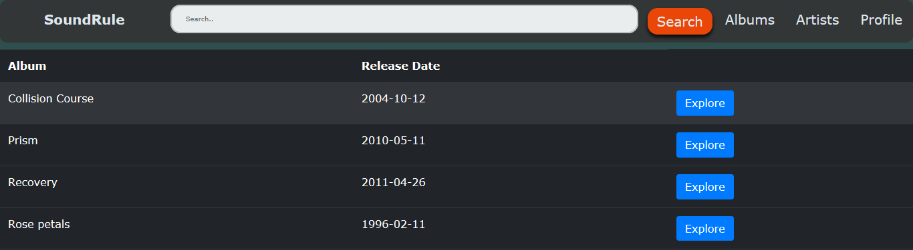

**Explore Album Page**

As soon as we click on Explore option on any album on the Album page we see all the tracks associated with this album. And the following page opens up.

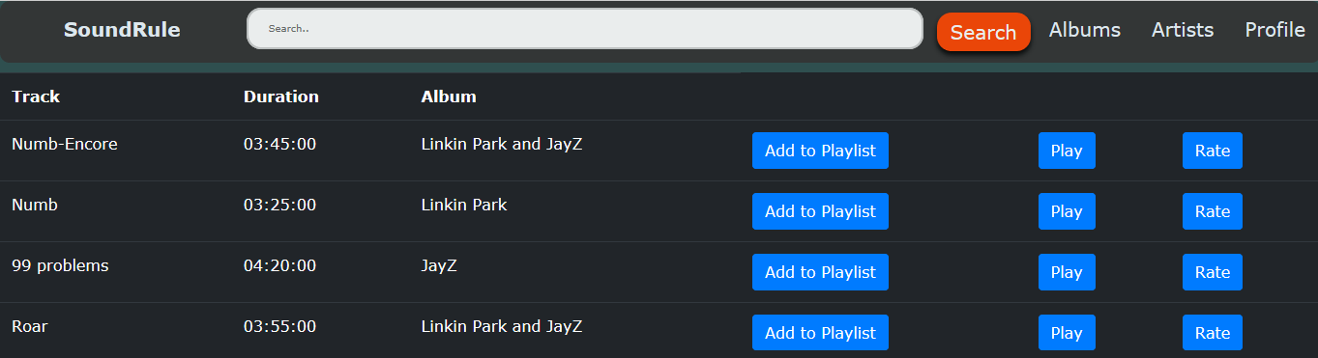

**Artists Page**

The Artists page is similar to albums page, just that it enlists all the Artists in the database, you can like the artist, or you can check out all the tracks associated to the artist.

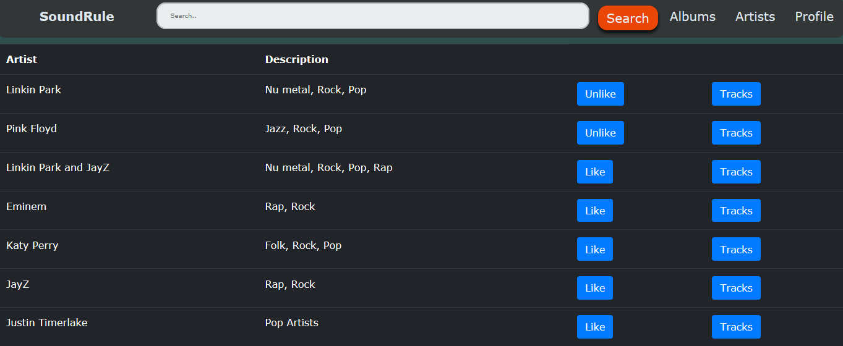

**Search Results**

The user can search through their favorite artist, track or album and based on the keyword enter the SQL query will search through the database the find the appropriate results.

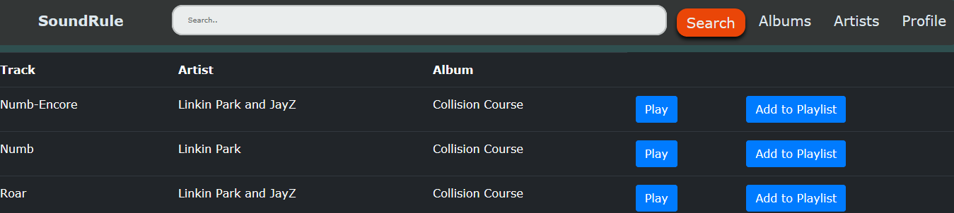

Here as we can see, user can either play that track or it can add to his/her playlist.

In case user tries to search something which is not available in the database, it will show and error message as shown.

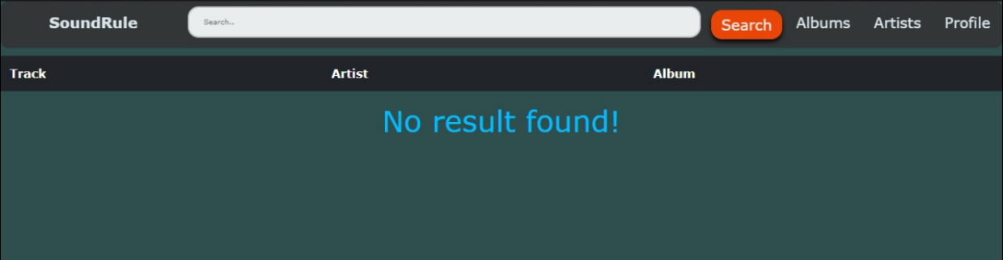

**My profile page**

My profile page offers user to checkout his details; edit them and his favorite artists and the people he/she follows.

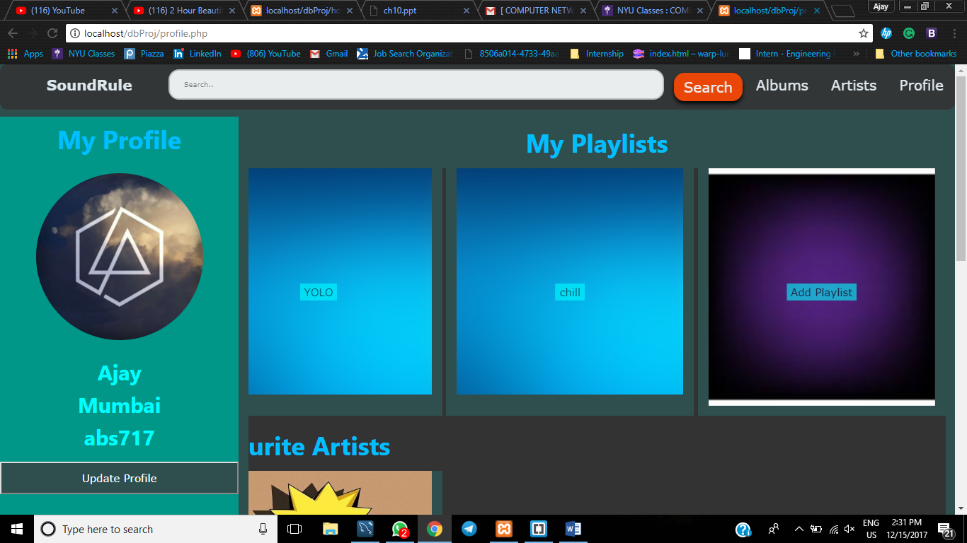

**Update Profile**

User can update the details of his profile like name, city and email address by clicking on update profile page.

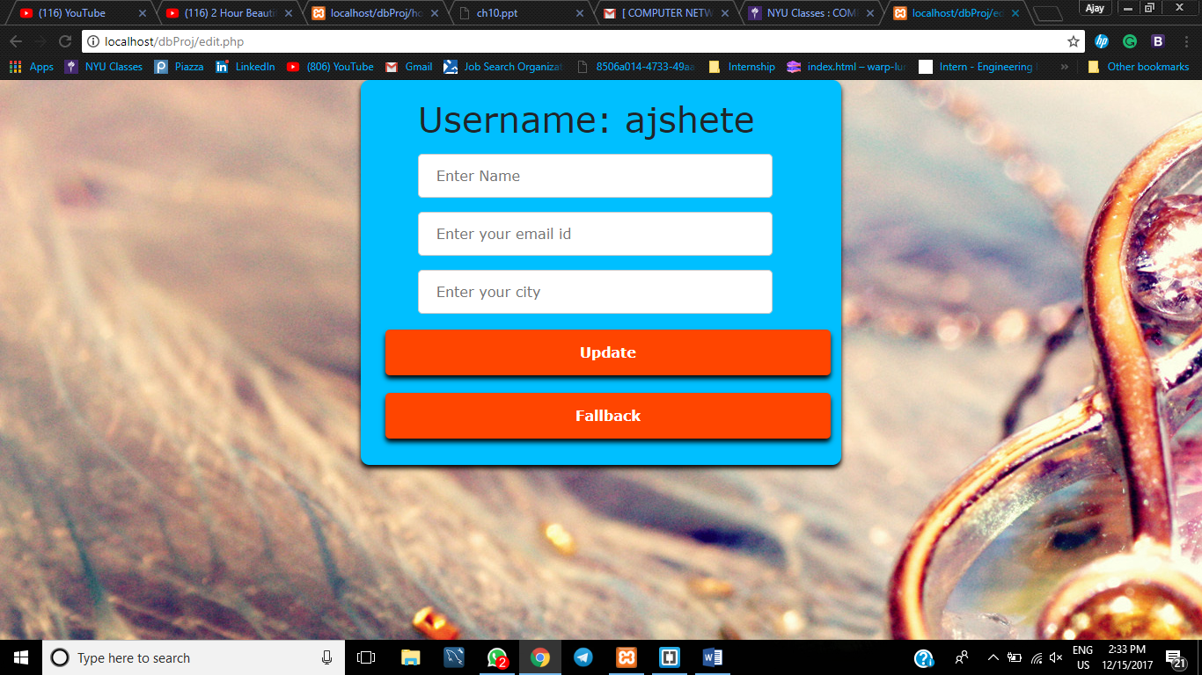

**History**

All the tracks that have been played by the user are shown by clicking on the check history page at the bottom of the profile page.

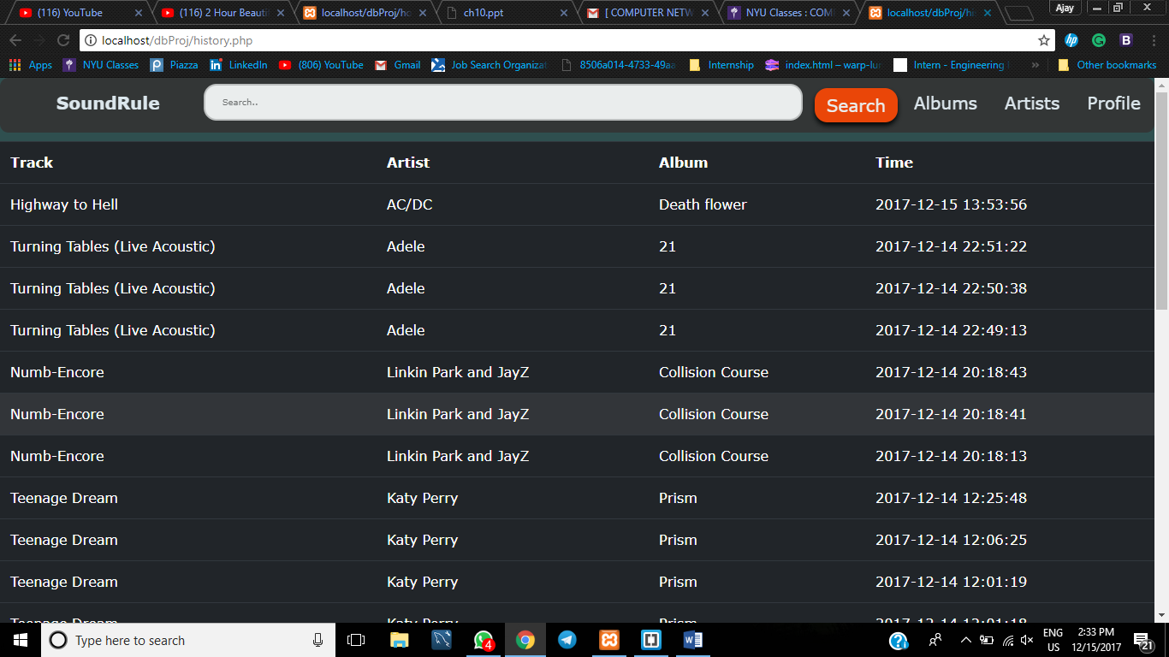

**Create Playlist**

User can create his own playlist and then add tracks that he wants. Further, he/she can keep it public for everyone to see or private.

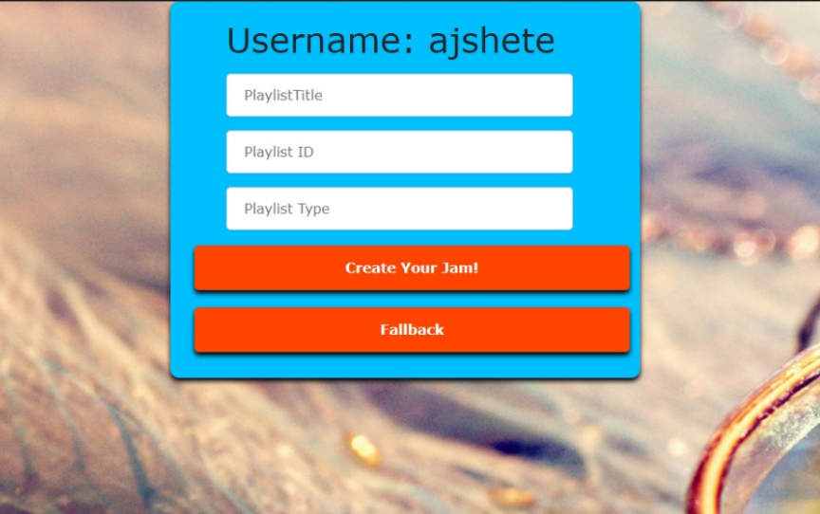

**Follow User**

One user can follow other users.

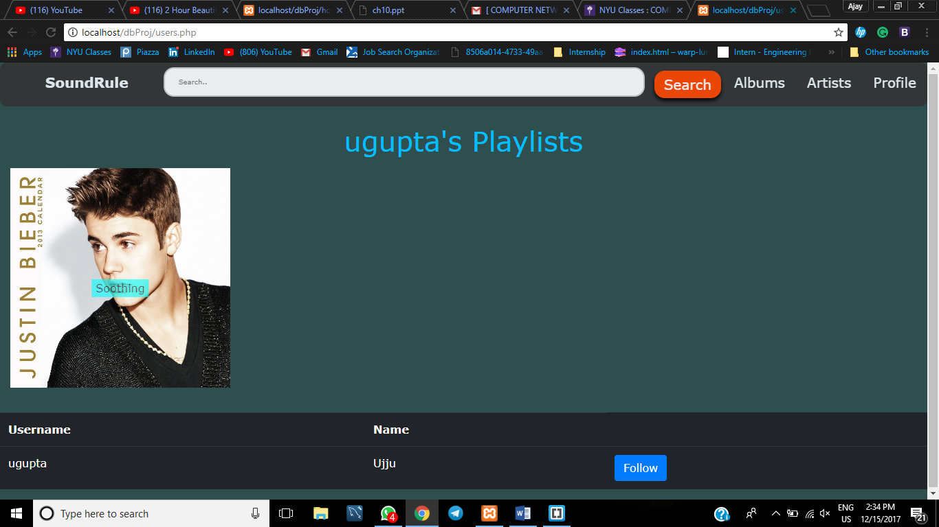

**Rating**

User can rate the track from 1 to 5

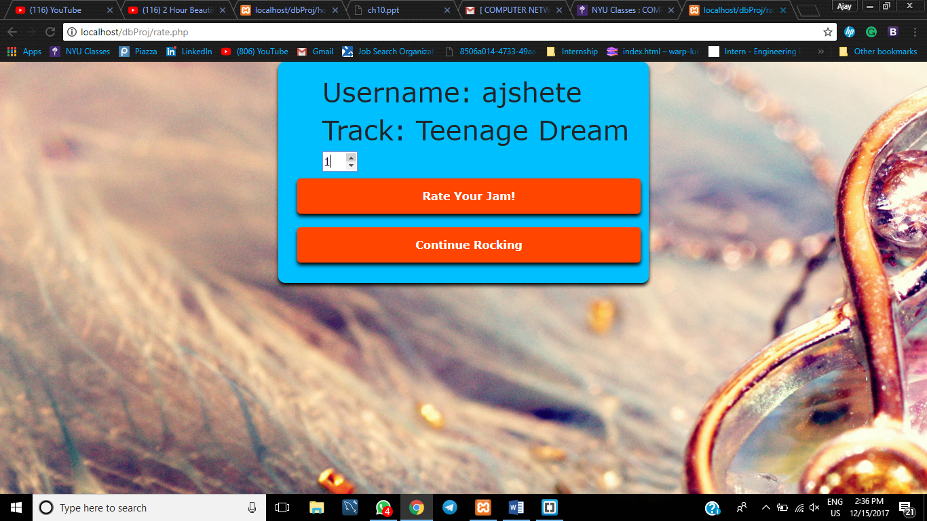

**Wamp**

We used wamp server as the local host, so wamp controls the MySQL queries and backend php

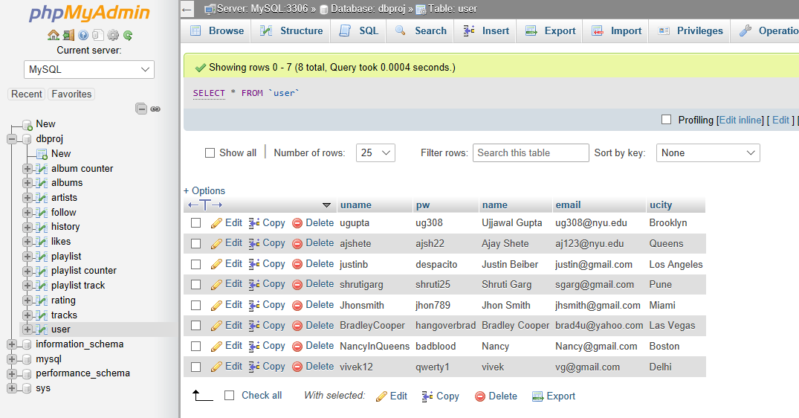

**Code Explanation:**

**Home Page**

**<?php**

require_once(**'**../dbProj_connect.php**'**)**;**

//include 'ps3_checkavailability.php';

if(isset($_POST[**'**login**'**])){

// echo '<form action = "http://localhost/ps3/bookings.php" method="post">';

$uname = $_POST[**'**uname**'**]**;**

$pw = $_POST[**'**pw**'**]**;**

$query1 = **"**select uname

from user

where uname = '**"**.$uname.**"**' and pw = '**"**.$pw.**"**'**";**

$response1 = @mysqli_query($dbc, $query1)**;**

while($row = mysqli_fetch_array($response1)){

$user_name = $row[**'**uname**'**]**;**

}

$query2 = **"**select aid, aname, adesc

from artists

where aid like '10_'**";**

$response2 = @mysqli_query($dbc, $query2)**;**

$query3 = **"**select abid, abtitle, abdate

from albums**";**

$response3 = @mysqli_query($dbc, $query3)**;**

$query4 = **"**select uname as user, name

from user

where uname != '**"**.$uname.**"**'**";**

$response4 = @mysqli_query($dbc, $query4)**;**

$query5 = **"**select name

from user

where uname = '**"**.$uname.**"**'**";**

$response5 = @mysqli_query($dbc, $query5)**;**

while($row = mysqli_fetch_array($response5)){

$name = $row[**'**name**'**]**;**

}

echo **'**<h1>Welcome **'**.$name.**'**</h1>**';**

if($user_name == $uname){

echo **'**

This code, displays the username, and fetches all the artists and albums from the database.

**Tracks**

if($response1){

while($row = mysqli_fetch_array($response1)){

echo **'**<tr>**';**

$tname = $row[**'**tname**'**]**;**

$tdur = $row[**'**tdur**'**]**;**

$abtitle = $row[**'**abtitle**'**]**;**

$tid = $row[**'**tid**'**]**;**

$abid = $row[**'**abid**'**]**;**

echo **'**<td align="left">**'** .

$tname .

**'**</td>

<td align="left">**'** .

$tdur .

**'**</td>

<td align="left">**'**.

$abtitle.

**'**</td>

<td align = "left">

<form action = "add.php" method = "post">

<input type="submit" name="add" value="Add to Playlist" class="btn btn-primary">

<input type = "hidden" name = "tid" value = "**'**.$tid.**'**">

<input type = "hidden" name = "uname" value = "**'**.$uname.**'**">

</form>

</td>

<td align = "left">

<form action = "tracks.php" method = "post">

<input type="submit" name="playArtHist" value="Play" class="btn btn-primary">

<input type = "hidden" name = "tid" value = "**'**.$tid.**'**">

<input type = "hidden" name = "aname" value = "**'**.$aname.**'**">

<input type = "hidden" name = "uname" value = "**'**.$uname.**'**">

</form>

</td>

<td align = "left">**'**.

**'**<form action = "rate.php" method = "post">

<input type="submit" name="rateArt" value="Rate" class="btn btn-primary">

<input type = "hidden" name = "tid" value = "**'**.$tid.**'**">

<input type = "hidden" name = "aname" value = "**'**.$aname.**'**">

<input type = "hidden" name = "uname" value = "**'**.$uname.**'**">

</form>

</td>**';**

echo **'**</tr>**';**

}

echo **'**</table>**';**

}

echo mysqli_error($dbc)**;**

This code fetches all the tracks from the database and arranges them in rows.

**Profile Page**

$uname = $_POST[**'**uname**'**]**;**

$query5 = **"**select name, ucity, email

from user

where uname = '**"**.$uname.**"**'**";**

$response5 = @mysqli_query($dbc, $query5)**;**

$row = mysqli_fetch_array($response5)**;**

$name = $row[**'**name**'**]**;**

$ucity = $row[**'**ucity**'**]**;**

$email = $row[**'**email**'**]**;**

$query1 = **"**select pid, ptitle, pdate, ptype

from playlist

where uname like '**"**.$uname.**"**%'**";**

$response1 = @mysqli_query($dbc, $query1)**;**

echo **'**

This query displays all the user information, like Name, email Id and password, user can further edit it if he wants.

**Playlists**

if($response1){

while($row = mysqli_fetch_array($response1)){

echo **'**<tr>**';**

$pid = $row[**'**pid**'**]**;**

$ptitle = $row[**'**ptitle**'**]**;**

$pdate = $row[**'**pdate**'**]**;**

$ptype = $row[**'**ptype**'**]**;**

echo**'**

<div class="container">

<img src="images/jb.jpg" alt="Avatar" class="image" name="" style="width:100%">

<div class = inner-but>

<form action = "playlistTrack.php" method = "post">

<button class = "btn-in-option" name = "playlistTrack" type = "submit">**'**.$ptitle.**'**</button>

<input type = "hidden" name = "ptitle" value = "**'**.$ptitle.**'**">

<input type = "hidden" name = "uname" value = "**'**.$uname.**'**">

<input type = "hidden" name = "pid" value = "**'**.$pid.**'**">

</form>

</div>

</div>**';**

}

On the profile page user can access his past playlists, to display that above mentioned code is used.

**Rate Track**

$uname = $_POST[**'**uname**'**]**;**

$abid = $_POST[**'**abid**'**]**;**

$tid = $_POST[**'**tid**'**]**;**

$score = $_POST[**'**score**'**]**;**

echo $score**;**

$query1 = **"**select tname from tracks where tid = '**"**.$tid.**"**'**";**

$response1 = @mysqli_query($dbc,$query1)**;**

while($row = mysqli_fetch_array($response1)){

$tname = $row[**'**tname**'**]**;**

}

$query2 = **"**INSERT INTO rating (uname, tid, score, rtime)

VALUES('**"**.$uname.**"**', '**"**.$tid.**"**', '**"**.$score.**"**', now())

ON DUPLICATE KEY UPDATE

score = '**"**.$score.**"**';**";**

$response2 = @mysqli_query($dbc,$query2)**;**

echo **'**

User can rate a track with a rating of 1 to 5, this code accepts that value and put an entry in the database.

**History**

$uname = $_POST[**'**uname**'**]**;**

$query1 = **"**select t.tname, t.aname, ab.abtitle, h.htime

from history as h join tracks as t on h.tid = t.tid

join albums as ab on t.abid = ab.abid

where h.uname = '**"**.$uname.**"**'**";**

$response1 = @mysqli_query($dbc, $query1)**;**

echo **'**

Whenever user plays any song an entry is made in the history database, this displays all the tuples.

**Follow User**

if($response1){

while($row = mysqli_fetch_array($response1)){

echo **'**<tr>**';**

$user = $row[**'**user**'**]**;**

$name = $row[**'**name**'**]**;**

echo **'**<td align="left">**'** .

$user.

**'**</td>

<td align="left">**'** .

$name .

**'**</td>

<td align = "left">

<form action = "users.php" method = "post">

<input type="submit" name="follow" value = "Follow" class="btn btn-primary">

<input type = "hidden" name = "user" value = "**'**.$user.**'**">

<input type = "hidden" name = "uname" value = "**'**.$uname.**'**">

</form>

</td>**';**

echo **'**</tr>**';**

A user can follow or Unfollow a particular user, this code sends and entry in the database if the user wants to follow or deletes one if he wants to unfollow.

**Update User Profile**

$uname = $_POST[**'**uname**'**]**;**

$name = $_POST[**'**name**'**]**;**

$ucity = $_POST[**'**ucity**'**]**;**

$email = $_POST[**'**email**'**]**;**

$query1 = **"**update user

set name = '**"**.$name.**"**',

email = '**"**.$email.**"**',

ucity = '**"**.$ucity.**"**'

where uname = '**"**.$uname.**"**';**";**

$response1 = @mysqli_query($dbc, $query1)**;**

echo **'**

<div class="center">

<div class="container">

<form action="edit.php" method="post">

<ul>

<li>

<h1>Username: **'**.$uname.**'**</h1>

</li>

<li>

If the user wants to update the profile, he can update the values like name, city and email id. The corresponding value will be updated in the database.

**Search Track**

$uname = $_POST[**'**uname**'**]**;**

$key = $_POST[**'**key**'**]**;**

$query1 = **"**SELECT t.tname, t.aname, ab.abtitle

from tracks t join albums ab on t.abid = ab.abid

where t.tname LIKE '%**"**.$key.**"**%' or ab.abtitle LIKE '%**"**.$key.**"**%' or t.aname LIKE '%**"**.$key.**"**%'**";**

$response1 = @mysqli_query($dbc, $query1)**;**

echo **'**

The user can search his/her favorite, artists or tracks, the keyword is search against all the tuples in respective tables, and then results are shown.

**Like an Artist**

$uname = $_POST[**'**uname**'**]**;**

$aid = $_POST[**'**aid**'**]**;**

echo $aid**;**

$query3 = **"**insert into likes (uname, aid, ltime)

values ('**"**.$uname.**"**', **"**.$aid.**"**, now());**";**

$response3 = @mysqli_query($dbc,$query3)**;**

$query1 = **"**select a.aid, a.aname, a.adesc

from likes l join artists a on l.aid = a.aid

where l.uname = '**"**.$uname.**"**'**";**

$response1 = @mysqli_query($dbc, $query1)**;**

$query2 = **"**select a.aid, a.aname, a.adesc

from artists a

where a.aid not in (select a.aid

from likes l join artists a on l.aid = a.aid

where uname = '**"**.$uname.**"**' )**";**

$response2 = @mysqli_query($dbc, $query2)**;**

echo **'**

user can also like an artist as we can see when the user clicks on like button , an insert query is generated and the entry is made in the database.

**Future consideration**

1. We understand that inserting and deleting and inserting again like in the case of Follows if a User wishes to follow and unfollow and refollow using Insert, Delete and Insert isn’t a good practice and as an revision shall make it try including a status variable to set status to work around this problem
2. Consecutively, we will also implement the same method for a user liking an artist.
3. We can create a trigger to notify the user every time an artist of his liking uploads a new song or album.
4. We will try to calculate the popularity of the song based on the ratings it has received, in addition to the play_count.